[**add your country/organization logos here**]

**Cost of implementing verbal autopsy as part of the routine Civil Registration system**

[Country name]

[Year of costing data]



This report was generated using the **VA Budgeting & Costing Tool** developed by the Swiss Tropical and Public Health Institute and the University of Melbourne as part of the Bloomberg Philanthropies Data for Health Initiative



# About the VA Budgeting and Costing Tool

The purpose of the Verbal Autopsy Budgeting and Costing Tool (‘VA Costing Tool’)[1] is to help planners and managers to determine the costs of implementing verbal autopsy systems.

This Tool can be customized to country context and covers all aspects of a verbal autopsy system comprising start-up costs, training costs, community-level service delivery costs, as well as support, supervision, and management costs at all administrative levels. Additionally, the Tool has a budgeting element that can be used to estimate budgets for VA systems.

The Tool automatically produces the following outputs:

* Total program costs for baseline year by activity and input type
* Average costs per VA
* Key drivers of costs.

The information collected could be used to strengthen budget preparation and justification in the annual budget preparation process; and to assist in verbal autopsy system implementation - measuring efficiency while identifying inefficiencies.

The VA Costing Tool consists of a single Excel file (.xlsx) where users define their assumptions for the costing exercise, collect general information about the country and cost information, and are provided with the results of the analysis. It is organized in three main sections: costing section, budgeting section and modelling section.

First, the tool allows to collect general information about the country and to define the assumptions for the analysis (eg discount rate, exchange rate, life span of different resources, etc.). Once this information is entered, the user moves to the second sub-section where all the cost data will be entered (*see green box in figure below*). The collection and analysis of VA cost is based on activities. We identified 6 groups of activities: start up activities, governance activities, program management, supervision, refresher training and VA delivery and analysis. Finally, a third subsection displays the results of the analysis based on the information entered in the previous steps (*blue box*).

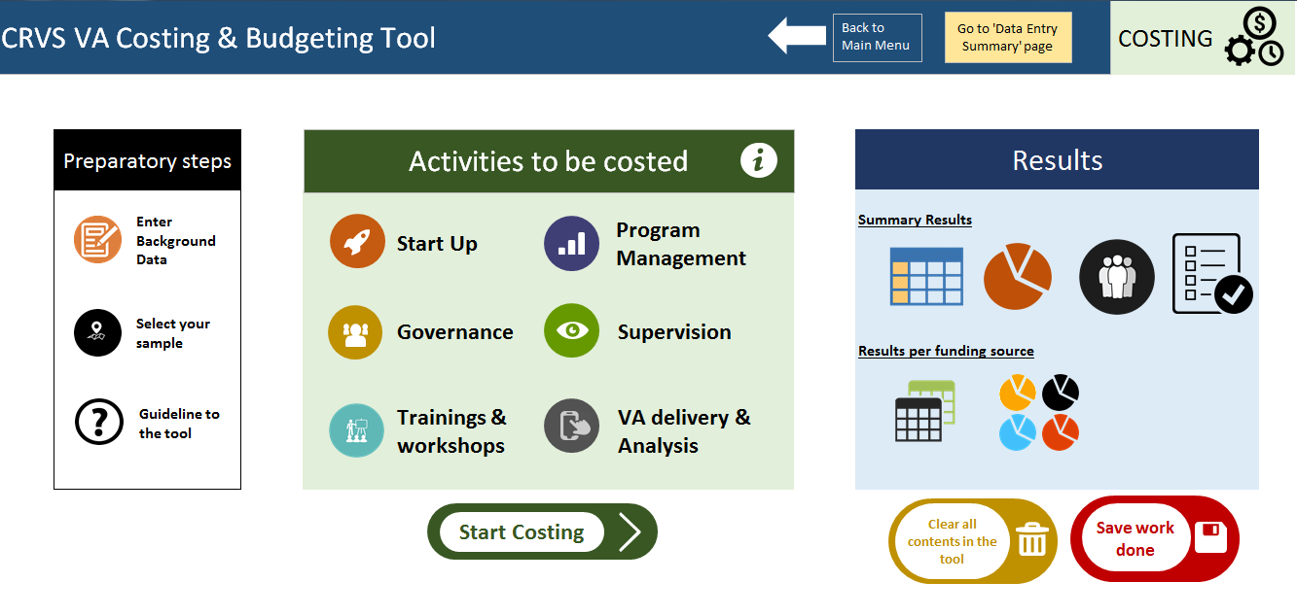

# Costing methodology

This tool considers both financial and economic costs. Financial costs represent the accounting cost of developing and implementing an intervention, whereas the broader notion of economic costs, captures the opportunity cost of the resources used in the intervention, whether or not a financial cost was incurred (i.e. even if they did not involve a monetary payment). Differences arise between financial and economic costs for goods or services for which there are no financial transactions, and where the price of the good does not represent its actual value. This is particularly important in programs with donated goods, working with volunteers or when valuing capital costs. The economic cost or value of donated goods and services will be estimated by taking their equivalent market prices. Therefore our tool estimates the incremental financial and economic cost of VA implementation in a country. It produces several cost estimates including total incremental cost, cost per VA, and further analyses and disaggregation (e.g. cost per funding source, cost per activity group or cost per type of resource used).

The tool assumes a systems perspective for the costing study where only costs incurred by the CRVS system are included and other costs such as household out-of-pocket expenses associated with death registration are excluded. Although choosing a more comprehensive approach with a societal perspective would be preferable, the objective of this study is to provide governments and other institutions with an estimate of the incremental cost of integrating VA into their CRVS routine system as an input for future policy decisions. As a consequence, this audience will be most interested in those costs that could fall under their budgets, rather than those incurred by households.

The tool estimates the incremental cost of implementing verbal autopsy. This means that only those additional resources used for VA activities will be included in the costing exercise. For instance, health professionals responsible for conducting the VA interview usually have other responsibilities as part of their job description. We would only include in the VA costing the per cent of time (equal to the % of their salary) spent directly on VA activities.

A combination of top-down and ingredient based methodologies is used to estimate the incremental costs of integrating VA into routine CRVS systems. An incremental analysis looks at the cost of adding or implementing the additional programme to existing services and does not attempt to provide cost estimates for existing services.

The top-down costing approach involves allocating overhead and shared costs of the CRVS system to the VA, where applicable, using appropriate allocation rules. The ingredient based costing approach is generally defined as a valuation technique which starts with a detailed identification and measurement of all the inputs required for an intervention, followed by conversion into value terms to produce a total cost estimate. In this study, the ingredients based approach are used to estimate the incremental costs for all VA related activities by listing all the possible inputs, measuring quantities and valuing all inputs required for a functioning VA system.

Activities related to the identification of the death event, notification to the system, data collection using the VA questionnaire on board a mobile tablet and ascertainment of the COD are included in the cost of conducting VA. Start-up activities such as trainings are also captured. The main resource inputs of verbal autopsy relate to training non-physician healthcare workers in data collection using a verbal autopsy tool, human resources for data collection, program management and infrastructure (i.e. fixed costs in terms of buildings, computers, tablets and maintenance of server; and variable running costs of the offices). The following human resource categories are considered and valued depending on the setting:

* Community volunteers
* Community outreach workers
* VA surveyors (interviewers)
* VA supervisors
* VA physician coders or signers
* VA IT, logistics and help desk
* VA analyst
* VA national coordinator

Total costs for the VA are estimated by aggregating the costs of the different inputs. Average/unit costs are estimated by dividing the total incremental costs by the units of outputs (i.e. number of VAs) produced. Unit cost estimates produced from this study will be used to model costs at full national or sample scale. Note that the same tool will be used for modelling estimated costs of alternative delivery scenarios in the three study countries, and possibly others.

# Costing results

## Background information

Provide a brief description of the setting:

* Country profile
* CRVS structure
* Activities involved in VA implementation
* Rationale of this costing exercise

|  |  |  |  |
| --- | --- | --- | --- |
| **General Indicators** | **Value** | | **Year** |
| Population (thousands) | |  |  |
| Population growth rate (%) | |  |  |
| Median age (years) | |  |  |
| Crude mortality rate (%) | |  |  |
| Birth registration coverage (%) | |  |  |
| Death registration coverage (%) | |  |  |
| Cause of death registration coverage (%) | |  |  |

|  |  |  |
| --- | --- | --- |
| **Economic Indicators** | **Value** | **Year** |
| Gross domestic product (GDP) per capita |  |  |
| Total health expenditures per capita, PPP |  |  |
| World Bank income classification |  |  |
| Average annual inflation rate |  |  |
| Average annual salary growth |  |  |

## Basic assumptions for the costing

Describe the assumptions made during the costing exercise and their rationale (e.g. discount rate, useful life of capital cost, unit cost of goods or services…

|  |  |
| --- | --- |
| **Assumption** | **Value** |
| Discount Rate |  |
| Useful life years of buildings (years) |  |
| Useful life years of equipment (years) |  |
| Useful life years of vehicles (years) |  |
| Useful life years of Trainings (years) |  |

## Regions or facilities included in the costing study

Describe the sampling frame and the rationale for selecting the sample in this specific VA costing exercise.

Sample

## Summary of cost of implementing verbal autopsy

Describe the main results of the costing exercise in the light of the methods and assumptions made during the costing exercise.

|  |  |  |
| --- | --- | --- |
|  |  |  |
| **Start Up activities** |  |  |
| **Governance activities** |  |  |
| **Refresher training & workshops** |  |  |
| **Program Management** |  |  |
| **Supervision** |  |  |
| **VA delivery & Analysis** |  |  |
| **TOTAL** |  |  |
| **Cost per VA** |  |  |

Graph 1

## Total cost of implementing VA per cost category

Report the disaggregation of the cost per input and discuss reasons for the cost structure.

|  |  |  |  |  |
| --- | --- | --- | --- | --- |
| **Input** |  |  |  |  |
| **Start-up costs** |  |  |  |  |
| Trainings, workshops & meetings |  |  |  |  |
| Other start up |  |  |  |  |
| ***Total start-up costs*** |  |  |  |  |
| **Recurrent costs** |  |  |  |  |
| Refresher trainings & meetings |  |  |  |  |
| Personnel |  |  |  |  |
| Communications |  |  |  |  |
| Maintenance |  |  |  |  |
| Supplies & other recurrent |  |  |  |  |
| ***Total recurrent costs*** |  |  |  |  |
| **Capital costs** |  |  |  |  |
| Buildings |  |  |  |  |
| Equipment |  |  |  |  |
| Vehicles |  |  |  |  |
| Consultants |  |  |  |  |
| ***Total capital costs*** |  |  |  |  |
| **Total Annual Costs** |  |  |  |  |

Graph 2

Graph 3

## Cost of implementing VA per funding source

Describe the distribution of cost per funding source.

Graph 4

## Share of the cost supported by each stakeholder

Donor

## Staff time allocation

Describe staff requirements as resulted from the costing study.

|  |  |  |  |  |
| --- | --- | --- | --- | --- |
|  | **Total number involved** |  | **FTEs\*** |  |
|  |  |  |  |  |
| **Community key informants** |  |  |  |  |
|  |  |  |  |  |
| **VA interviewers** |  |  |  |  |
|  |  |  |  |  |
| **VA supervisors** |  |  |  |  |
|  |  |  |  |  |
| **VA physician coders or signers** |  |  |  |  |
|  |  |  |  |  |
| **VA IT logistics and Help desk** |  |  |  |  |
|  |  |  |  |  |
| **VA analyst** |  |  |  |  |
|  |  |  |  |  |
| **National manager & supervisor** |  |  |  |  |
|  |  |  |  |  |
| **Sub-national manager & supervisor** |  |  |  |  |
|  |  |  |  |  |
| **Consultant** |  |  |  |  |
|  |  |  |  |  |
| **Other** |  |  |  |  |
|  |  |  |  |  |
|  |  |  |  |  |
| **\*FTE: Full Time Equivalent** |  |  |  |  |

# Conclusions/summary

(Optional) – provide a brief overview of main results and implications







1. Available at <https://crvsgateway.info/file/10396/3144> (direct download of excel file)